Annual General Meeting
22nd March 2020
Supplementary Minutes due to AGM Cancellation as a result of COVID 19 Social Distancing Request from the UK Government

Normal Attendees – Representatives from:
BAF, KAA, DAN, UKA, BB, Trowbridge Aikikai
Apologies

- Approval of Minutes of Last Meeting

- The minutes of the meeting held on 7th April 2019 were available but not approved. Approval will be sought at the next AGM (2021) or if an EGM is organised.

- Chairmans Report
This is pretty much a regurgitation of my report from 2019 as most things mentioned last year are applicable to this year.
I would, of course, like to thank’s all those involved in the smooth running of the JAC;
Guy Needler, general secretary
Allan Hagan, treasurer
Sue Yates, insurance registrar
Eddie McCalla CPO (I hope I have spelt his name correctly this time; I got in awful trouble when I put together the 2020 JAC seminar poster!!)
Both the treasurers and the insurance registrars positions are up for re-election at this meeting and I would like to thank Allan and Sue for all of their work over the last few years, should they hand over to others later in this meeting; they will be a hard act to follow.
In the main, this has been a quiet but good and steady year for the JAC. We maintain our excellent relationship with the Aikikai and Hombu dojo. We had, as far as I am aware, one instance of an injury claim was being put to our insurance providers, but the injured party decided not to proceed ultimately. That is a very good position to be in for an organisation of our size, despite the fall in numbers from last year.
As I said last year, with financial uncertainty, the first thing that has to go is leisure activities and I think we are all doing well to recruit the sort of numbers that we have as members of the JAC. I know we are all trying rally hard, within our respective organisations, to recruit and more importantly, retain new members. Please keep up your efforts and the good work you are doing as we, obviously, want as many people as possible to practice aikido the Aikikai way.
Despite our excellent, injury free efforts, our insurance providers have seen fit to increase our premium. Consequently, we have needed to increase the amount paid by individual members by £1 to cover this increase but there will no increase in the cost of the cover for dojos. As you will see in Allan’s report shortly, the JAC does have a float but it is not big enough to absorb this increase so, unfortunately, we must pass this on to the JAC groups. As sports insurance cover is a niche market in the insurance world, we have limited options when it comes to obtaining the services of a different provider.
At the AGM 2021 the chair’s and the general secretary’s posts will be up for change/re-election. The UKA and the BAF have supplied chairmen so far in the life of the JAC so I would like to invite nominations from our other groups, British Birankai, Scottish Aikido Federation, Komyokan Aikido Association or Dynamic Aikido Noquet for the post and if you could advise the general secretary of nominated persons by the end of the year, that would be helpful. Of course, the general secretary’s role is open for any applicant, should anyone see fit to take it on.
I will continue in my role for the next 12 months and do my absolute best for our organisation, but I do not have the monopoly on good ideas of how to progress the JAC as we move forward. Any ideas that may help us progress and promote our art in the UK will be gratefully received.
I thank you all for your efforts to promote British Hombu recognised aikido. We are held up by the Aikikai as the template for umbrella groups throughout the aikido world as a result of all of our efforts and long may that continue.
With reference to the JAC June Seminar we need to watch the COVID 19 progress closely to see if this will run or be postponed/cancelled.

- General Secretary’s Report
Membership
As Mr Yates stated it’s been a quiet year this year (apart from the last 2 weeks) with all things JAC running smoothly.
However, the JAC membership has dropped by 310 members overall with the biggest drop experienced by the adult members. Having said this, we have increased our dojo count by 22 and our instructors by 27.
We need to get more members and will need to invoke better marketing to attract them.
See below for more membership details.
Special thanks to Sue for providing the membership details.

JAC Insurance Sales 2019-2020
(2018-2019 in Red)
7 Member Organisations (Currently)

Student Adult | Student U18 | Instructor | Venue (club)
802 (1109) | 198 (201) | 269 (242) | 112 (87[121 in 2018)
Total Membership
1000 (1310)

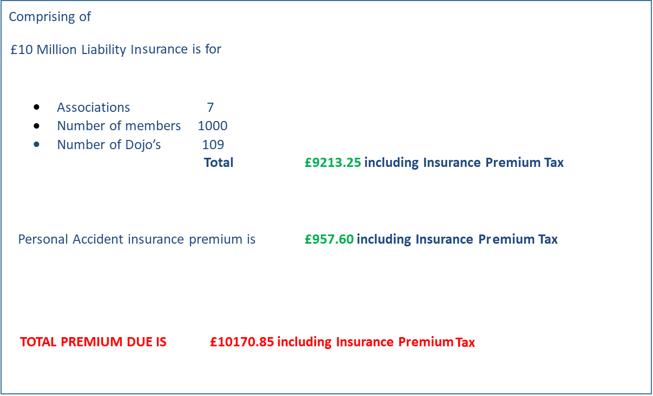

The British Birankai has fractured and we now have a new group emerging, The British Aikikai.

Insurance for the BB and BA membership will remain as is and as soon as the BA gain Hombu recognition the JAC will accept them as a full member and the description of the JAC member organisation number will be modified for organisational insurance purposes.

The Excess Layer Insurance is no longer with Barbican because they have pulled out of such insurance.

Hiscox backfilled so that we now have £10M cover but the Hiscox premium is now more than 2019’s combined Hiscox and Barbican Premium.

In 2019 We had £5M PL cover with additional £5M excess layer cover which equaled a premium of £6938.46 (Hiscox) Plus £1232.80 (Barbican) plus PA insurance £944.47 (RSA) or a total of £9115.73.

In 2020 We have £10M PL cover £ 9,213.25 (Hiscox) plus PA Insurance £957.60 (RSA) or a total of £10170.85 or £1055.12 extra.

As a result the insurance fees need to be increased as follows:-

2020 – 2021 JAC Membership and Insurance Fees

Dojo registration £50.00
Membership - Student £2.00
Organisation Insurance per student £4.00 (previously £3.00)

Insured Age

The insurance provider will only cover up the age of 80 on the overarching policy. Unfortunately, anyone aged over 80 should seek to obtain their own insurance.

- Treasurers Report
The report was approved by Allan Hagan as Treasurer, David Yates as Chairman and Guy Needler as General Secretary.
The financial statement and notes can be made available to JAC members upon request to Allan Hagan. A summary is below.

Income and expenditure account for the year ending 29th February 2020
Income |  | 2019/20 | 2018/19
 | Notes |  | £
C/F |  | 17356.55 | 16029.57
Organisation fees | 1 | 0 | 0
Members, dojo fees | 2 | 11765.00 | 10475.00
Course Income | 3 | 685.00 | 763.65
Total Income |  | 29806.55 | 27268.22
Expenditure
Personal accident cover | 4 | 957.60 | 860.79
Public liability cover | 5 | 9213.25 | 6638.30
Excess Liability |  | 0.00 | 1176.00
Public Liability Adjustment |  |  | 664.80
Secretary PO Box Annual Charge | 6 | 114.00
AGM 2020/19 | 7 | 275.00 | 182.40
Travel expenses |  | 0 | 0
Website Expenses |  | 139.04
Coach tutor course exes | 8 | 389.20 | 389.38
Total Expenditure |  | 11088.09 | 9911.67
Surplus for year end |  | 18718.46 | 17356.55

Approved by;
David Yates (Chairman)
Guy Needler (General Secretary)
Allan Hagan (Treasurer)

Notes to the accounts 2019/20.

- Each of the six JAC member organisations and the JAC itself, are covered for combined insurance liability. At the 2017 AGM it was passed that this amount would be paid from JAC surplus (in this instance it’s for 2019/20).
- The figure represents, in total, all monthly insurance returns submitted by organisational representatives for individual members and dojo insurance cover, based on the amounts collected; £50 per dojo insurance premium, £4 per individual insurance premium, £2 per individual JAC membership.
- This figure covers the income from ALL association coach courses and the JAC annual course held in 2019.
- Personal accident cover paid to Howden in March 2020 on the numbers of members and dojos within the 6 member organisations throughout the year 2019/20.
- Public liability cover paid to Howden in March 2020 based on the number of individual members and dojos of the JAC member organisations.
- PO Box Charges, provides an anonymous address for written communications to the JAC.
- Costs incurred to arrange the 2020 AGM. Room hire and refreshments.
- The costs incurred to put on coach tutor courses and to cover the costs of any of the association coach level 1/2 courses that showed a small deficits.

- Election of Officers
Treasurer
Membership Secretary

- The positions of treasurer and membership secretary were due for re-election. As no other candidates presented themselves and the AGM was not actually held due to the COVID 19 virus the current incumbents will stand until either an EGM or an AGM (2021?) can be robustly organised.

- Any Other Business
Next JAC course (June 2020 – BAF – Chester)
The June 2020 JAC seminar will be hosted by the BAF.
Main contact is David Yates.
The seminar is currently due to be held but the committee members are closely watching the COVID 19 status.
JAC website
Control of the JAC website is now with Gregg Duckett who is proving to be a great asset.
Thanks
A vote of thanks was put forward for all the work that Greg Duckett and Paul Emmerson have done in migrating and updating the JAC website and David yates as Chairman.
Supplementary Minutes compiled by GSN

