Annual General Meeting
22nd April 2018

Attendees:
BAF
Sue Yates, David Yates (also SAF Proxy), Allan Hagan, Tony Doherty
KAA
Stella Stevenson, Jeremy Garmson
DAN
Paul Emmerson, John Emmerson
UKA
Gordon Jones, Guy Needler
BB
Ian Grubb
Trowbridge Aikikai
Robert Hill
Apologies
Bryan Bateman, Terry Ezra

- Approval of Minutes of Last Meeting

- The minutes of the meeting held in Birmingham 22nd April 2018 were approved by those present. Proposed Paul Emmerson, Seconded Ian Grubb.

- Chairmans Report
Chairman’s report 2019,
Firstly, I would like to thanks all those involved in the smooth running of the JAC;
Guy Needler, our tireless general secretary
Allan Hagan, our ruthless treasurer and
Sue Yates, our dogged insurance registrar.
This has been a relatively quiet year for my first year as the chair of the JAC. We had an excellent annual seminar in Durham, hosted by DAN and special thanks for that and the charity fund raising initiative, must go to Paul Emmerson. Thank you Paul. A great effort by you and all of your team members. I’m sure that the 2019 annual seminar, to be hosted by the UKA on 2 June, will be equally as successful.
On the down side, slightly, numbers within all of our organisations are dropping. This, of course, is not unique to aikido. All leisure activities are suffering due to various reasons, not all of which are Brexit related although I suppose it is in vogue to blame that for everything! As people find money and time less available, the first thing that realistically has to give is a leisure activity. With one or two notable exceptions of people who are good enough and experienced enough to have turned aikido into a profession, we are all practising aikido as amateurs and purely for the love of it.
We must and I know I’m pushing against an open door with you in the room today, work a little harder to expand our dojos, thereby our organisations, thereby the JAC and thereby British aikido. Any innovative ideas to do this will be gratefully received and I’m sure with the experience in this room, we can give serious thought to how to push this on.
When I was in Japan last November, I went along to a re-opened dojo (it had closed when the previous sensei became unable to continue with his practise) and I was amazed with the number of elderly people who had just started to train. Obviously we need younger people to take our art into the future but please don’t forget that more mature, possibly, retired people have more time on their hands and may well be looking for something to keep them active and supple.
Finally, from a personal point of view and a view I’m sure many members of the JAC will appreciate; British aikido has lost a tremendous talent very recently. I know Kanetsuka sensei was not everybody’s cup of tea but there is no getting away from the fact that he was a huge influence on British and overseas aikido generally and upon a few of us older end, more directly. I thank him for what he did for me and for us, although there were times as I’m sure a number of you will agree, that I didn’t always see it for what it was or what he wanted. I will miss him.
- General Secretary’s Report
Membership
Sue Yates assisted with the presentation of the membership data and stated that, due to late submissions the membership figures were based upon a point in time and the figures used to secure our insurance premium for 2019-2020.
Sue also asked for Instructor (Dojo) insurance fees to be collected by 31st January to assist in the payment of overall insurance premium.
Membership report for JAC (Thanks to Sue Yates for the Data)
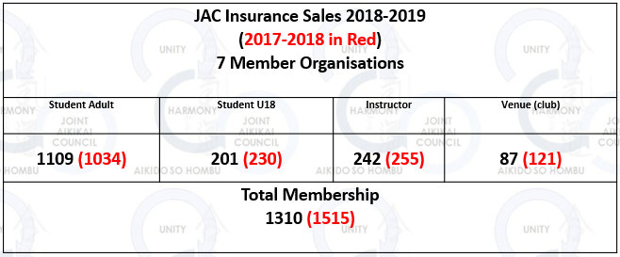

2019 – 2020 Insurance Costs
The JAC business wording was not consistent with the understanding of our insurance cover. It has now been changed to:
For Practise
“Whilst Participating in the Martial Arts of Aikido including recognised Training / Practice and official Social Events at JAC and non-JAC member organisations world-wide.”
For Teaching and Organising
“Whilst administering the sport of Aikido in respect of JAC and affiliated Associations/ Clubs, and when requested, non-JAC member organisation seminars as guest instructors world-wide.”
Insured Age
Currently we are insured up to the age of 75 – increases still under discussion!
GSN will communicate with the insurers to ascertain if we can have cover for “named” individuals who are 75 and over but under 80 and 80 and over but under 85 as two age groups.
Some attendees noted that "Towergate" insure students in their 80's and asked if we could move our insurance to them.
GSN stated that prior to this he would investigate the following opportunities.
1) Ask the insurers to ascertain if we can have cover for “named” individuals.
2) these individuals would be in two groups
3) Those who are 75 and over but under 80 and...
4) Those who are 80 and over but under 85
We would like to compartmentalise this/these additional premium/s so that those concerned can pay the additional premiums in lieu of it affecting the premiums of the majority of the members.
The member organisation reps were asked to send Sue Yates the names of students and instructors who are within these age groups.

2019 – 2020 JAC Membership and Insurance Fees
All increases were discussed and agreed at the 2018 AGM
Dojo registration £50.00
Membership - Student £2.00
Organisation Insurance per student £3.00
Previously we charged £45 per dojo and £2 plus £2 JAC membership per individual members.
- Treasurers Report
Allan Hagan presented a full financial report and explanation for the supporting detail. The report was approved by Allan Hagan as Treasurer, David Yates as Chairman and Guy Needler as General Secretary.
The financial statement and notes can be made available to JAC members upon request to Allan Hagan. A summary is below.

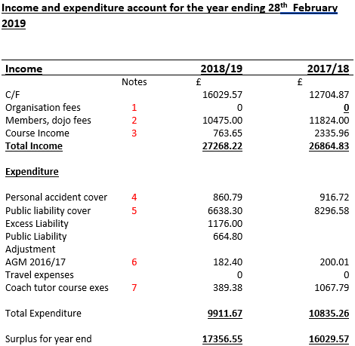

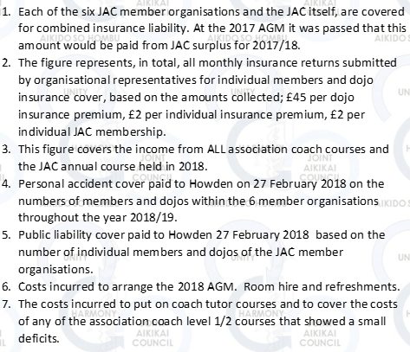
Notes

Adjustments to the method of presentation of the JAC accounts was discussed with Mr Ian Grubb. Mr Hagan will liaise with Mr Grubb to affect suggested changes to the methods.
JAC Dropbox directory
GSN has changed the directory structure to add in the document subject headings for ease.
- Election of Officers
General Secretary
- The position of General Secretary was due for re-election and Guy Needler offered himself for re-election. With no other candidates GSN was re-installed into the position.

- Any Other Business
Peter Brady - Minoru Kanetsuka Memorial
Mr Gordon Jones acknowledged the lifetimes work of both Kanetsuka sensei and Peter Brady. All attendees were in agreement about the loss of these two Aikido Masters.
Organisational Fragmentation
Mr Jones commented about Hombu’s approach to 6th and 7th dans leaving the JAC member organisation of their origin, creating smaller organisations and gaining autonomy and Hombu recognition for their yudansha grades.
It was agreed that during the May 2019 visit to Hombu that Mr Jones would seek a meeting with Tani san to express concern.
Next JAC course (June 2019 – UKA Ren Shin Kan Dojo - Dudley)
The June 2019 JAC seminar will be hosted by the UKA.
Detail are available via Mr Neil Mould – UKA seminars secretary.
Mat fee £25 per full day.
The 2020 JAC seminar will be hosted by the BAF. Details to follow.
JAC website
Phil Hadfield has formally handed over management and control of the JAC website to Gregg Duckett.
Concerns over compatibility with coaching data via Moodle will be addressed by Gregg when he creates the new website.
JAC YouTube Channel
Phil Hadfield has agreed to be the JAC YouTube broadcaster.
An update on progress is required.
GSN to contact Mr Hadfield to gain the latest status.
Summer School Synergies
GSN has written to Tani san and Ito Shihan to see if there is the possibility of sharing the same Hombu Shihan over both UKA and BAF summer Schools. This would mean that the BAF and UKA summer schools would need to be back to back and that we could share the costs of having a Hombu shihan in a future summer school
It is noted however that the BAF 2020 summer school dates are not yet know and that they would need to be the datum to work from.
A possibility of an overlap with the BB summer school with the UKA is also being considered. This would not be the primary goal for 2020 though.
It was also noted that this may not come into fruition in 2020 but may be possible in 2021 if Hombu agree to this possibility.
GSN has been invited to a meeting with Tani san and Ito Shihan when he is at Hombu in May.
No commitments should be made until all facts are known and that these facts are discussed with the relevant people in the BAF, UKA and BB
Small Organisations and Membership to the JAC via a Member Organisation
The committee had a long discussion about groups joining the JAC via an existing member organisation.
The main consideration was how these groups fit into the structure of the JAC if they were only joining for insurance purposes and were not governed by the JAC group they joined though. For example, yudansha examinations that were then submitted to Hombu by another route rather than the JAC group.
The JAC constitution clearly states that to qualify as member groups of the JAC, a group must either have Hombu recognition or be seeking it and the existing small groups that are currently member via a member organisation appear only loosely aligned to a JAC via the member organisation, and it would appear, only to get cheap insurance rates.
It was noted by GSN that although the UKA had a number of such groups as JAC members via the UKA that all of the members of these groups pay full UKA membership/insurance fees and are, therefore, full UKA members. They have even attended UKA seminars and UKA instructors have participated in gradings and seminars as instructors. However, it was noted by the Chair that these small groups seem to be sitting with one foot in each camp, with the UKA and with some other Hombu shihan with whom they are registered as yudansha for Hombu purposes.

Although, how the UKA organise their memberships is, of course, a matter for the UKA there was a concern that this could create issues with the JAC insurers should a claim be lodged. This means that they would have to claim as a JAC/UKA member. However the UKA seniors would be ultimately responsible for the circumstances that created the claim and this responsibility would need to be backed up with personal knowledge of their levels of practise. If their member attend UKA/JAC courses and are known to the UKA seniors, then everything is in order except in the instance that they are not known
The Chair stated that the JAC wants as many people as possible to study aikido the Hombu way and all JAC member groups adhere to this principal. The Chair noted that the JAC need to be clear of the quality of practise of these groups, who may only have minor links to Hombu, if they do not practise regularly under the direction of a Hombu recognised organisation?
It was decided that this issue was a point to be discussed in the near future. The JAC processes for accepting small organisations as member are attached for reference.

Thanks
A vote of thanks was put forward for all the work that Greg Duckett and Paul Emmerson have done in migrating and updating the JAC website and David yates as Chairman.
Meeting closed 15:36
Minutes compiled by GSN

