Annual General Meeting
22nd April 2017

Attendees:
BAF
Sue Yates, David Yates, Nick Belshaw, Tony Doherty,
KAA
Terry Ezra, Stella Stevenson, Jeremy Garmson
DAN
John Emmerson
UKA
Gordon Jones, Guy Needler, Phil Smith
BB
Ian Grubb
Apologies
Ray Gardiner, Bjorn Saw

- Approval of Minutes of Last Meeting

- The minutes of the meeting held in Birmingham 10th April 2016 were approved by those present. A request for the title and date on the next set of AGM minutes was made and actioned in these minutes. Proposed Ian Grubb, Seconded John Emmerson.

- Chairmans Report
Thankfully it has been an uneventful year for aikido in the JAC.
I would like to offer, on behalf of all JAC members, our thanks to Dave Yates, who is giving up his role as treasurer, a role he had had since the inception of the JAC. He has been one of the invaluable building blocks of the JAC and his position of treasurer has given us a stable financial start these last 5 years.
Along with Sue Yates and Guy Needler he has been a driving force in making the JAC work as well as it has. We also owe both Sue and Guy a vote of thanks for the contributions they have made in our success. Also, I would like to record the vast amount of work Phil has done in creating a workable coaching schedule, it has been one of the most difficult aspects of the JAC’s progress.
On the subject of thanks, I would like to record our thanks to Greg Ducket and Phil Hadfield who have done some vital work on the website. Like to thank Paul Emmerson who has been a driving force in getting the work done.
There are some items on the agenda that we covered last year that we need to reconsider. There are possibly some issues around coaching… insurance… IAF… Sports England, that may cause some debate. Events in the UKA have shown me that aikido relationships can be very fragile, and I see my job as chair is to ensure, as much as possible, that unexpected cohesion that the JAC has achieved over the last 9 years, is maintained for the future. This united relationship has brought added value to our members and enhanced our collective relationship with Hombu beyond any expectations.
We are in the fortunate situation of creating our own rules and boundaries, therefore I hope that we can achieve a full consensus of opinions on the items under discussion today, and continue working in harmony for the coming year.
Gordon Jones

- General Secretary’s Report

- Little to Report. The JAC we are now in a “normalising” position.
Hombu
- Hombu still using JAC as a template for others to follow and we are happy to continue to receive new members resulting from Hombu direction.
- Hombu want the JAC to join the IAF (See AOB)
- John Emmerson commented upon Hombu’s lack of concurrence of the D.A.N application for recognition. Subsequently to the AGM GSN communicated with Tani-san in Hombu who stated that D.A.N matched the criteria and that the matter needed to be closed and recognition issued ASAP. It transpired that some documents were lost, which caused the delay. These have now been re-sent. Recognition is expected before the end of June 2017.
Membership
As a result of insurance concerns it was decided to remove the Affiliate Membership. This creates equality and removes ambiguity in the insurance policy.
Updates supporting documentation describing the process for new member applications for organisations over 100 members, small organisations under 100 members and individual dojos was presented and approved by those present. These documents are now in the JAC DropBox subdirectory. (accessible via the JAC website)
Membership report for JAC (Thanks to Sue Yates for the Data)
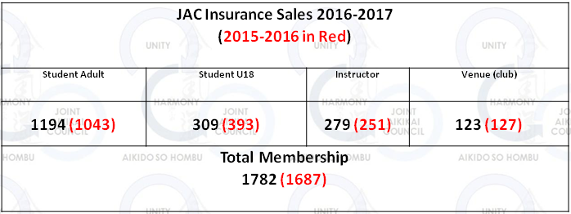

2017 – 2018 Insurance Costs
Dojo £45
Member - Student £2
Member – Instructor £2
Insurance questions should be sent directly to Sue Yates
- Treasurers Report (JAC – year ending 29th February 2016)
David Yates presented a full financial report and explanation for the supporting detail. The report was approved by David Yates as Treasurer, Gordon Jones as Chairman and Guy Needler as General Secretary.
The financial statement and notes can be made available to JAC members upon request to David Yates. A summary is below.
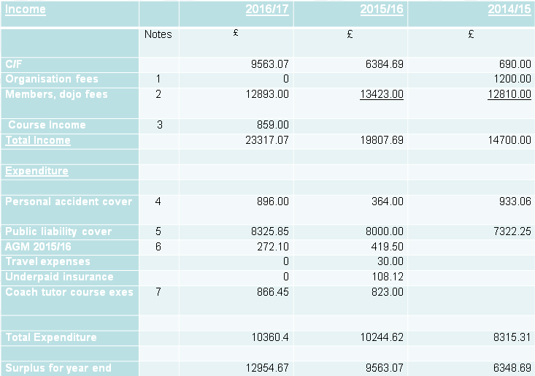

- Insurance
The JAC insurance Schedule for 2017/2018 will be on the JAC (DropBox link) and Perkins-Slade websites.

- Election of Officers
Treasurer
- David Yates formally stood down as treasurer and Allan Hagan was accepted as nominee. The JAC thanked David for his time and efforts.
- Allan Hagan was proposed by Phil Smith and Seconded by Terry Ezra. Allan is now the JAC Treasurer for 2017-2019
General Secretary
- With no other nominees submitted Guy Needler was happy to continue in the role of General Secretary.
- Guy Needler was proposed by Ian Grubb and seconded by Phil Smith. Guy is no the General Secretary for 2017-2019
Chairman
- The Chairman will be re-elected in 2018’s AGM

- Any Other Business
JAC and the IAF
- Tani-san (Hombu) wishes the JAC to join the IAF
- BAF and SAF already members for England and Scotland
- Possible changes to IAF statutes to allow additional members to the IAF from the same country
- IAF congressman, Dorin Marchis, is sympathetic to the JAC but the next congress is in 2020 where changes to the statutes may include acceptance of more than one organisation representing a country on the IAF council.
- GSN has asked Mr Marchis if an application can be made parallel to any favourable changes to the statute, otherwise an application could be made in the 2024 congress.
Coaching
- Notes from P Smith were discussed with reference to changes to the Sport England coaching requirements. In light of this the following changes are to be made which must be in place together with a new syllabus by July 2017.
- Level 1 – Coaching under supervision of a Level 2 coach
- Level 2 – Coaching without supervision and can mentor a Level 1 coach
- Level 3 – National and international coach
- Level 4 – International coach (Under development but progressing. Dates for introduction are on the Sport England Website. A link to book on-line may be available soon)
- Phil also explained the coach validation and revalidation process and reasons for it. Documents in support are available and have been broadcast by Phil.
- Coaches need not be First Aiders but a First Aider must be present in the dojo.
DBS is required for those coaches who are “regularly” teaching children.
Next JAC course
- The Next JAC course was discussed and agreed to be on the 3rd June 2017 in Wirral hosted by KAA.
- The 2018 JAC course will be hosted by D.A.N and will be in June 2018. Paul Emmerson has been asked to organise on behalf of the JAC
- Each member organisation is requested to propose an instructor to represent them. Tony Doherty to organise.
- Additional JAC courses to be organised 2 years in advance.
- Instructors will receive a fee to reimburse for traveling
- JAC to provide financial support to hosting organisations
JAC website
Various updates were made to the JAC website and are identified below.
- Safeguarding link added to the website
- To add details about the AGM to the website
- To add the CL1/2 material to the website (Coach Transition Process; Coach Evaluation Form and Coaching Awards)
- Set up a page that will contain links for each member organisations seminars timetable, which should all be in the same format.
- Set up a contact us page (with the content emailed to all three of you). This contact page should also include: One email link as well to allow the requester the opportunity direct rather than via a contact us fire wall if they need to discuss something. An attachment function for people to send their seminar timing plans via (suggest the best format for you to use and that they should send)
- We should have a way of identifying where dojos are...(a map?) If I was looking for aikido in my area i would have to scroll through 7 JAC web sites to find local info. There are dozens of local dojos looking to pick up new members we are possibly loosing out to.
- JAC needs to be more web visible to people looking for Aikido not Aikikai. Should we change name to incorporate aikido or add it to our title somehow?
- Website says JAC represents ALL Hombu recognised groups, this isn't the case it should read 'all major groups' or something like that. We intend to petition Hombu for more visible support
- Member groups should be able to upload course info directly. From what Greg says this is available now...but not sure that it is widely known about. We decided that each group should have web point of contact, as far as the UKA is concerned this hasn't happened. Need to address this by making sure all group heads are fully aware.
- A DropBox link for all JAC process documents
JAC YouTube Channel
- The possibility of a JAC YouTube channel was discussed to ensure that only “Quality” Aikido was broadcast by the JAC and was in line with IAF and Hombu requirements.
- The JAC asked John Emmerson if Paul Emmerson would be willing to accept the role as JAC YouTube broadcaster. John took the request away.
Thanks
A vote of thanks was put forward for all the work that Phil Hadfield, Greg Duckett and Paul Emmerson had donated to update the JAC website.
Additional thanks were also offered to David Yates for his devotion to the JAC in the role of Treasurer.
Meeting closed 15:39
Minutes compiled by GSN

