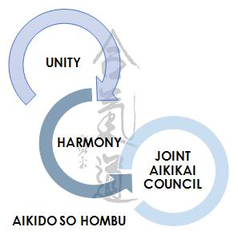
January 2017

Dear Member,
In April of 2017 coaching regulations and recognition will change for all sports coaches in the UK.
Basically from this date only coaches who hold a level 2 award or above (no matter what the sport) will be insured to teach without supervision. In other words CL1 award will only allow an instructor to teach if at least a CL2 is present to supervise them.
The JAC has arranged with our insurers that a transition period until 1st July will be in force to allow present CL1 teachers to continue to teach and give them time to obtain a level 2 award.
Therefore please read and act on the information the information below so that this transition is a smooth as possible.
1. Until July 2017 CL1 coaches may continue to teach unsupervised but they must upgrade to CL2 by 1/07/2017. From 1/7/2017 CL1 can only teach under the supervision of a CL2 coach, but CL1 can be awarded from the grade of 1st Kyu rather than Shodan as at present.
2. All current level 1 coaches who have been teaching for a period of five years or more prior to July 2017 should complete the attached document (appendix 1); this should then be passed to the association Coach Tutor(s) for assessment. Following assessment by the Coach Tutor the coach will then be recognised as a Level 2 coach or asked to submit further evidence as appropriate
3. Current level 1 coaches who have been teaching for less than 5 years (prior to July 2017) must complete a JAC Level 2 coaching programme.
4. The JAC shall adopt the re-validation requirements for all coaching levels as outlined in the attached revalidation documents (appendix 2)
5. Current Hombu Shihan shall be exempt from the revalidation process
All completed portfolios must be returned to your association coach tutor(s) by 1st June 2017 so that they can be processed in time for the change in the terms of our insurance.
Many thanks for your understanding
Philip Smith (on behalf of the Coaching Advisory Group)

